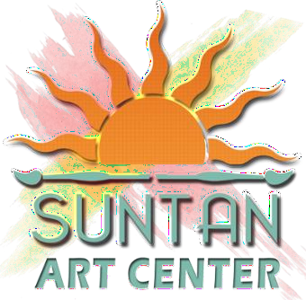

# Pop-Up Guidelines and Application

Suntan’s Saturday Pop-up

3rd Saturdays 10am-3pm

* Only artwork/prints/mixed media art made by the artist is permitted.
* Suntan has the right to deny any artist participation if they are not presenting their work.
* You are representing Suntan and must remain professional at all times.
* You must have a payment method, such as Square, PayPal, Venmo or cash apps. Please do your research before signing up, so that other vendors do not have to explain how to take payments to you.
* You are required to bring tables, along with table covers. Tents are recommended but not required; however, please bring something to protect you from the sun and weather.
* This is a rain-or-shine event, there will be no refunds or credits.
* The road will be closed at 21st Street and Central, we will take care of permitting along with The Speakeasy Kava bar.
* Payment is due by the first of the month, I will send out a reminder a few days before.
* Approval for a permit takes 14 days; we will be setting up every third Saturday.
* Space assignments will be given out before the event.
* Your membership with Suntan is an option; however if you are not a member you will not be permitted to participate in other Suntan Events.
  + The cost for non member sign up is $60+tax
  + The cost for member sign up is $35+tax
* The event starts at 10am, be there with enough time to set up.
* There is no parking in any spot behind the Kava bar, this is for employees only. There is plenty of street parking, and off street parking.

**By signing up for SUNTAN ART ON CENTRAL you indicate you understand the guidelines**



# Suntan Art Center ART ON CENTRAL Application

Name: Address:

City: State: Zip: Phone: Cell Email: Website: Instagram: Facebook

Twitter:

Are you a Suntan Art Center Member: Yes: No:

Product Type:

Painting (all mediums) Clay Fiber/Textiles/Leather

Glass Jewelry Metal

Mixed Media Music Graphics/Digital Art

Sculpture Wood Photography

Furniture Other: Description of Products:

Please include 3 – 5 images of the items intended to be sold at the market in addition to 1 image of the booth or display that will be used. Digital images are preferred. Send your images and application to **craftsmenmgr@suntanart.org**

Signature: Date: